
b

The Data
Reference Model
Management Strategy
Review Draft August 18, 2006



The Data Reference Model
Management Strategy

Table of Contents
Table of Contents i
Executive Summary 1
Introduction 3
DRM – What is it? 6
DRM – Why is it important? 12
DRM – Who are the key players? 14
DRM – How will it work? 16
DRM – What are its strategic goals and outcomes? 21
APPENDIX A: List of Acronyms 24

Executive Summary

It is common knowledge that information technology advancements have made it easier to search, exchange, and process information. The strategic opportunity is to make the technology work in support of government results. It is increasingly important for senior leaders to understand their organization’s business needs for data, and design the most efficient solutions for delivering it.
The government must work in real time, critically, constantly and dynamically gathering and processing data whether they are to support rapid disaster recovery, homeland security or provide benefits to citizens. Our ability within the federal community to quickly discover, access, and understand data and information must mature beyond what has been accomplished in our first wave of E-Government solutions.
Enterprise Architecture provides the most strategic of our tools to manage the complexity of the information we manage. A well built enterprise architecture allows leadership to ask the tough questions, such as: “Do I have all the information to achieve my goals or to make the strategic decisions I face every day? Is my investment in data and technology cost effective?”
By aligning strategic goals, organizations, business processes, information flows and technology across the Federal Government, the Federal Enterprise Architecture (FEA) makes it possible for departments and agencies to operate as a single enterprise with a cost effective blueprint for improving program performance. The Federal Enterprise Architecture Reference Models, including the Data Reference Model (DRM), help to counterbalance the daunting complexities of technical scale and specialization, enabling strategic dialogue among the right parties to get their mission’s work done.
Until now, there has been no effective common data architecture framework for departments and agencies to use for supporting cross-agency and intergovernmental shared business goals. The FEA DRM is designed to provide that common framework for the cost effective sharing of government information across organizational lines while respecting the security, privacy and appropriate use of that information. It enables agency leaders to manage information as a national asset to better serve the American public.

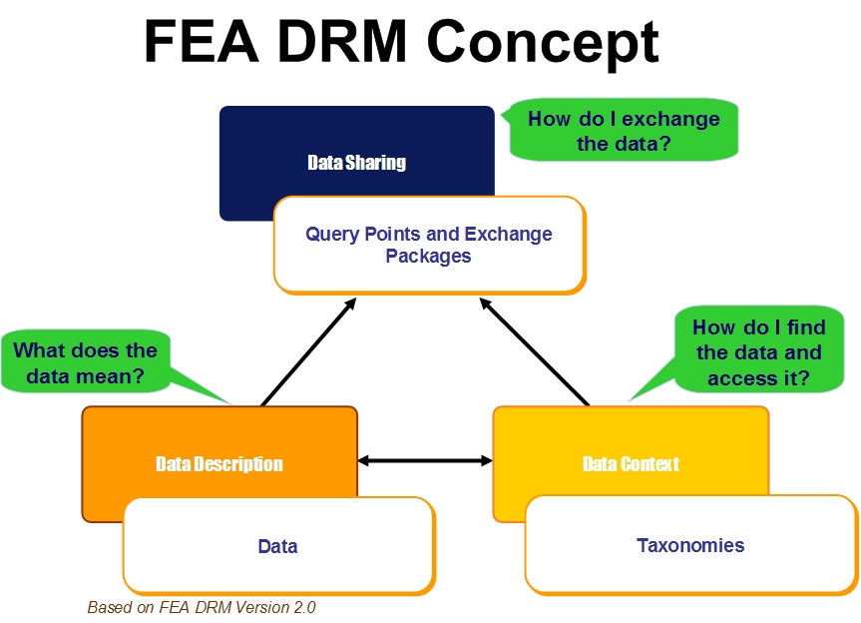
Figure 1. FEA DRM Concepts.

As illustrated above, the DRM provides a starting point and organizing mechanism for establishing collaboration around data to meet mission needs. The current strategy calls for the DRM to be a catalyst; multiplying the value of existing “silo” data holdings through better understanding of what the data means, how to access it and put it to work supporting performance results. The end result is to make data “high-performance” and ready to meet critical needs for real-time relevance—the right information to the right people at the right time, from multiple sources.
Implementing the DRM should logically lead to a fewer small, incompatible information systems and therefore a future where data reuse, shared systems and core capabilities, used widely across those shared systems, deliver better information to those who need it, at far less cost. This will surely be appreciated by state, local and tribal governments, industry, scientific community, academia, and, specifically, the general public.

Introduction

The practice of data and information management is multi-dimensional. It is critical to the functioning of a knowledge-intensive government, yet represents one of government’s toughest business challenges. While some government data need to be exposed to the public and made discoverable, other data have to be managed and protected. Getting the right information to the right people at the right time is at the heart of the second generation of E-Government. We need a data and information strategic approach for the challenges we currently face and the unknowns ahead of us.
What makes data management challenging is that the data are either hidden in the processes that produce them or are not available in a commonly understood fashion. For example, when a citizen makes a reservation at a National Park, this citizen sees a simple web display such as the one illustrated in Figure 2. What the citizen does not see is the data behind the display, as illustrated in Figure 3.
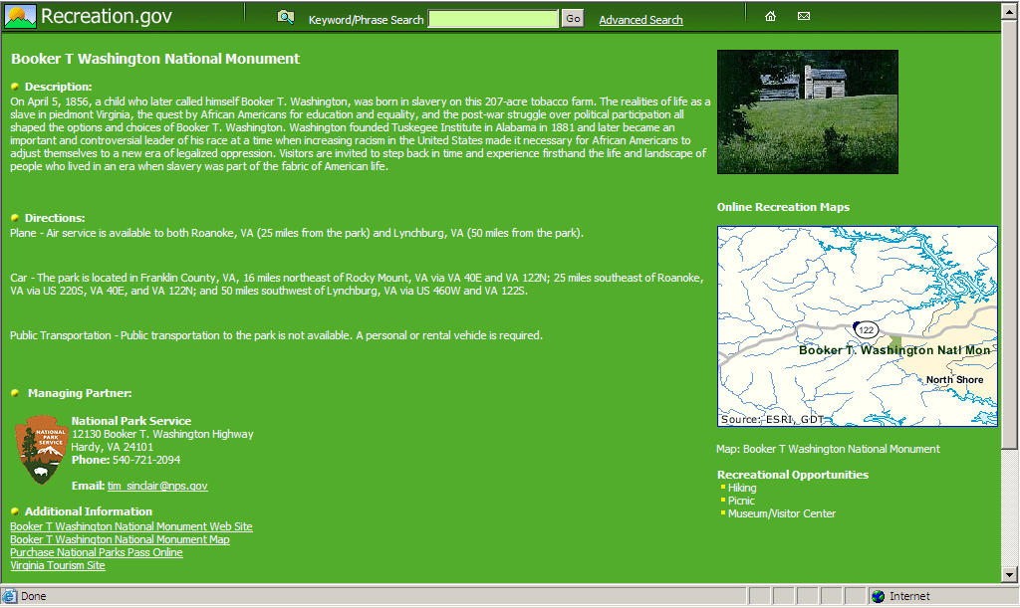
There are many repeated instances when data, not unlike the data displayed in Figure 3, is vitally needed and could be used by one or more other agencies. Agencies that have a need for this type or source of data, but lack awareness that it already exists, can end up spending additional time and scarce resources to recreate the same or similar data to support their individual missions. The lack of data visibility and accessibility results in costly redundancy of data within and among government agencies. Until now, we have not had the catalyst for a solution that the DRM provides.
Figure 2. Citizen View of Recreation Reservation.
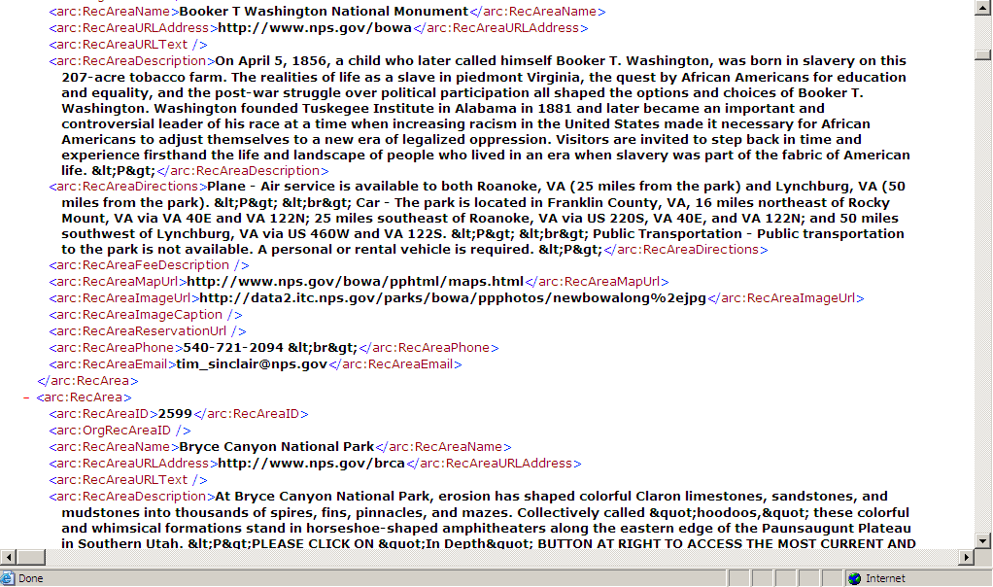
The challenges of information sharing are known to all senior government officials but have become especially mission critical recently to many, especially in programs requiring rapid data acquisition and analysis to save lives or prevent unthinkable events. This effort required to prepare the federal government for this revolution in data awareness and readiness cannot be addressed with a top-down approach or merely with a set of data communities and grassroots efforts; rather it demands a more strategic and tactical approach. The DRM enables the Federal Government to begin to address the following key questions many are asking:
Figure 3. Technical View of Recreation Reservation.
- How do agencies discover what data are available for sharing and re-use?
- How do agencies, with data available for sharing and re-use, make it visible and accessible?
- How do agencies ensure procedures for security privacy, quality and appropriate use of the data shared are considered and followed?
- How do agencies reduce unnecessary redundancies in the collection and storage of data?
- How do agencies drive down IT system costs through effectively managing their data?
- How do agencies improve consistent access to and dissemination of government information to promote a more citizen – centered government?
- And, perhaps the most critical question is: how does the Federal government create rapid information sharing when responding to a time sensitive event or crisis?
New technologies and the standards for their use and implementation are increasingly available, but it is the strategic vision, which is needed to enact real results.. This vision is contained here and in the revised DRM and also incubated in the leadership postured to implement it.
The following chapters answer five key questions about the DRM:
- What is it?
- Why is it important?
- Who are the key players?
- How will it work?
- What are the strategic goals and outcomes?

DRM – What is it?

The DRM is a reference-able conceptual approach (or model) that can be used to facilitate information sharing and reuse across the Federal government. It increases the federal government’s agility in drawing out the value of information as a strategic mission asset.
As illustrated in Figure 4, the DRM concept is structurally based on three standardization areas:
- Data Context: Facilitates discovery of data through the categorization of data. Additionally, it facilitates the identification of authoritative data sources for a business process.
- Data Sharing: Supports the access and exchange of data where access consists of ad-hoc requests (such as a query of a data asset), and exchange consists of fixed, re-occurring transactions between parties.
- Data Description: Provides a means to uniformly describe data, thereby supporting its discovery, sharing and standardization.
The terminology used in Figure 4 corresponds to DRM Version 2’s abstract model. DRM Version 1 discussed business context in terms of subject area and information class. These terms still apply in DRM Version 2. It also decomposed data element into data object, data property, and data representation, which is in accordance with ISO/IEC 11179. The abstract model in Version 2, however, describes entities containing attributes, which are in turn constrained by data types. Version 2’s entity corresponds to Version 1’s data object, attribute to data property, and data type corresponds to data representation.
The DRM facilitates an agency’s understanding of, from its own perspective and leveraging other agencies’ data categorizations, the access or exchange methods used, the conditions or constraints of the data, and how the data can be utilized.

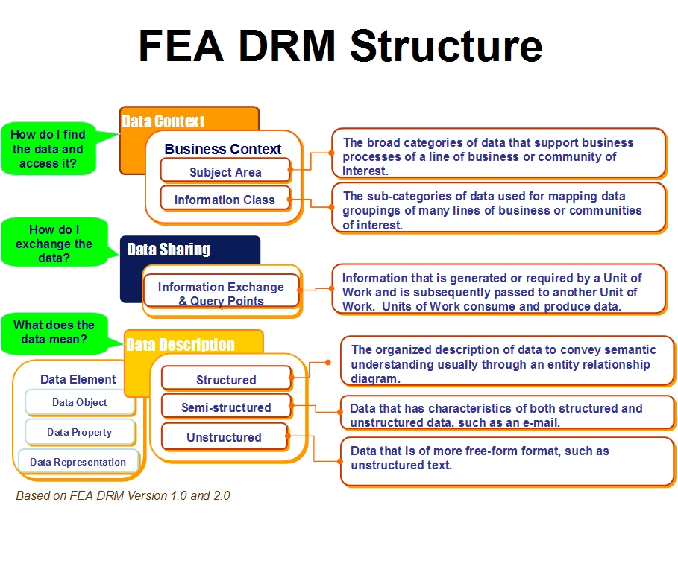
Figure 4. FEA DRM Structure.
Departments and agencies with mature data architectures and data management processes will find that mapping to the DRM provides them with capability to work across the federal government on strategic information needs. On the other hand, other departments and agencies that are in the initial stages of establishing their data architectures and data management processes should find the DRM particularly useful as the starting point.
To gain a fuller understanding of the DRM, it must be looked at within the context of the Federal Enterprise Architecture. Enterprise Architecture provides the most strategic tools to manage the complexity of the information challenge.

The DRM is now at the heart of the FEA’s complete and current set of reference models, which are, as of the date of this publication:
- Performance Reference Model (PRM) Version 1.0
- Business Reference Model (BRM) Version 2.0
- Data Reference Model (DRM) Version 2.0
- Service Component Reference Model (SRM) Version 1.0
- Technical Reference Model (TRM) Version 1.1
These interrelated Reference Models are touch points, or frames of reference, allowing departments and agencies to design their own Enterprise Architectures, while providing management mechanisms to identify, analyze and, where appropriate, facilitate Lines of Business (LoB) to engage in opportunities for collaboration and strengthen cost efficiencies.
To further illustrate how the DRM works in an Agency’s Enterprise Architecture, consider the scenario outlined in Figure 5 for the Recreation One Stop initiative. A senior government official can strategically look and “see” that to achieve a specific performance goal (PRM), a strategy he or she may pursue is to promote and enable scheduling access to recreational facilities (BRM), data is needed to develop the rules and processes enabling the public access (DRM), which is dependent on content management provided by information technology (SRM/TRM) to deliver the information necessary. Therefore asking questions of the Enterprise Architecture will point out, from a performance goal and business perspective, when information is missing or if it exists where it should be located. Equally important, through the FEA Reference Models’ connections, other departments and agencies can understand what information DOI has for recreation and can position themselves to reuse the information.
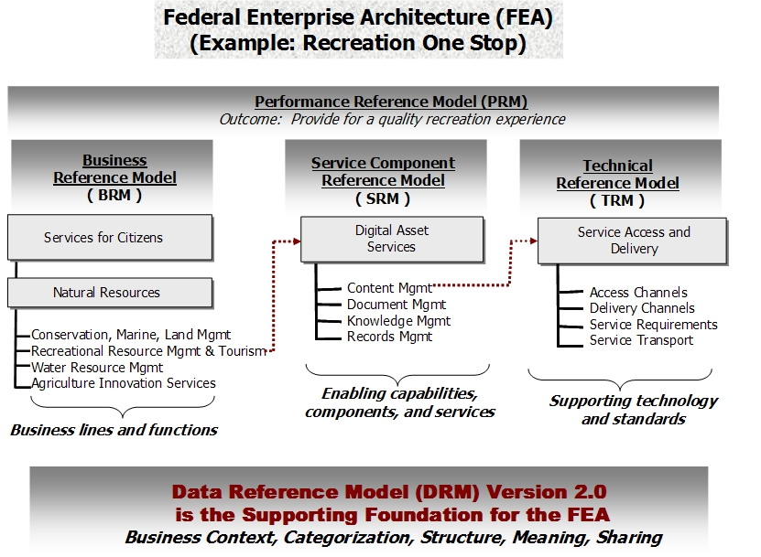
Figure 5. FEA Architecture Reference Model Relationships.

In actuality, more than one area of the DRM may aid in the answer key questions. For example, Description would aid in how to find data, as well as how to understand it. Using each of the DRM areas answers multiple questions.

Data Context: What is the data that I need for my mission and how do I find it?
Data Context facilitates the ordered categorization of data in a business/mission context to help an agency understand what data (no matter what its format - text, maps, data in analytical systems) is needed to support a particular line of business or mission. Data categorization will also help in the identification of duplicative data resources, discovery of data for reuse and enhancement of search capabilities.

Data Sharing: How do I exchange data?
Data Sharing is the process that provisions the data from an information source to an information consumer in order to meet a business requirement. Advances in technology create the opportunity for the easy provisioning of data across organizations for mission results.
The DRM is a catalyst for streamlining our information sharing mechanisms and avoiding stove pipe approaches. It will be greatly appreciated by and create cost savings for state, local and tribal partners, who deal with multiple federal departments and agencies.

Data Description: How do I understand what the data means?
Data Description improves and facilitates the understanding of data, both in terms of finding it and processing it, once it is obtained. It is the reference point to identify authoritative data standards and also the point to identify when standards need to be put in place to serve a cross agency mission need. It is not enough to be able to find and access data; for decision-making data must be of trusted quality.
The DRM was designed to address a very real challenge: how to make the most efficient use of our investment in data. If one agency already collects the data and it can be appropriately reused, why place an additional reporting burden on the regulated community or state and local /tribal governments? The DRM provides the guidance to strategically support a department or agency in understanding the data it has, within the context of the federal government’s entire data holdings, so it can be deployed cost effectively and with appropriate usage.
The DRM also facilitates data interoperability, harmonization and, to some extent, standardization across the federal government in response to identified business and mission needs.
As enumerated below, the DRM supports government leaders in fulfilling their responsibilities under existing policy and law.
- Maximize the practical utility of and public benefit from information collected by or for the federal government and reduce collection burdens on the public (GPRA & OMB Circular A-130)
- Seek to satisfy new information needs through interagency or intergovernmental sharing of information, or through commercial sources where appropriate, before creating or collecting new information (OMB Circular A-130)
- Implement processes to organize and categorize government information (E-Gov Act)
- Identify how information and data are created, maintained, accessed and used (OMB Circular A-130)
- Define agency data and describe relationships between mission and program performance and information resources to improve the efficiency of mission performance (OMB Circular A-130)
- Define data and describe relationships among data elements used in the agency’s information systems and related information systems in other agencies, state and local governments and the private sector (OMB Circular A-130)
- Adopt a basic standard of data quality (including objectivity, utility and integrity) as a performance goal and incorporate information quality criteria into agency dissemination practices (Data Quality Act)
- Establish and maintain inventories of all agency information dissemination products and develop other aids to locating government information dissemination products, such as catalogs and directories (OMB Circular A-130 & OMB M-05-04)
- Comply with and support the achievement of objectives under Executive Order 13356 and Homeland Security Protection Directive-11.
- Improve Public Access to and Dissemination of Government Information (OMB -06-02)

The DRM was designed to support the legislative and policy requirements that the federal government already has in place. The DRM advocates and supports information sharing, where appropriate conditions are met to enable it such as in agreements between departments and agencies in response to business and mission needs and within their correct and proper legislated authorities and legal practices.

DRM – Why is it important?

Currently, individual federal government organizational elements create data to support the specific business processes that they’re responsible for executing. Federal government information management has been previously criticized for locking up data in unconnected stovepipe legacy systems. Now they must view the data as a national asset. The DRM supports the emergence of repeatable processes that enable agencies to discover, share and seamlessly exchange data and information relevant to meet business objectives.
Federal Chief Information Officers (CIOs) and Chief Financial Officers (CFOs) are in a unique position to ensure that information required for a strategic goal or business objective is quickly and easily located, accessed and understood by those who need it. To achieve superior performance results, they must manage both the strategic, tactical and operational data and information needs of their agencies. They must also be in partnership with the other elements of the government infrastructure.
The DRM, as a value proposition, assists federal business leaders, CIOs and CFOs in:
- Mapping from business and mission goals to data and information usage
- Providing an explicit link between the business needs of an agency and its data services and technologies.
- Discovering which data is available for sharing and reuse
- Making visible and accessible data that is available for reuse
- Ensuring that procedures for security, privacy, quality, and appropriate use of the data shared are considered and followed.
- Reducing unnecessary redundancies in the collection and storage of data
- Driving down IT system costs through effectively managing data
- Improving consistent access to and dissemination of government information
- Designing rapid information sharing in responding to time sensitive events or crises

Implementation of the DRM will facilitate improvement of the Federal Government’s collective ability to cost effectively deliver the right data to the right person at the right time, as illustrated in Figure 6. This approach is driven by each agency’s and department’s mission to find the “right information” to meet their stakeholder and user needs.

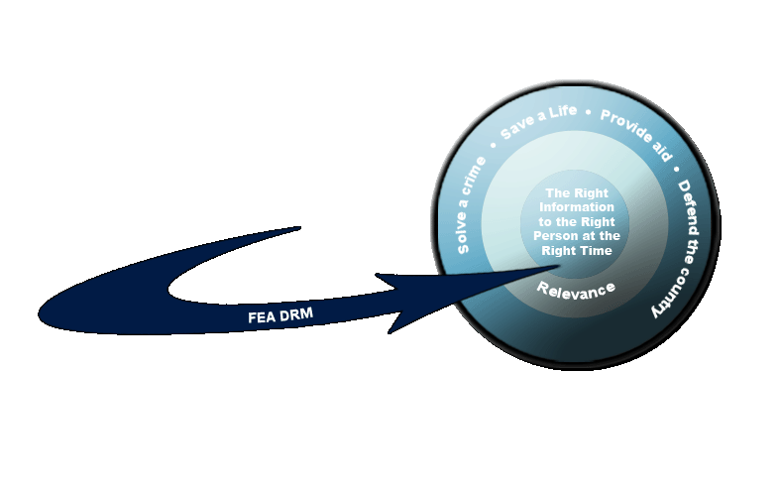
Figure 6. DRM Targets the Right Data to the Right Person at the Right Time.

DRM – Who are the key players?

The CIO Council’s Architecture and Infrastructure Committee (AIC) has chartered a new federal-wide Data Architecture Subcommittee to realize the value proposition of the DRM.
A key to the DRM’s success is detailed governance capabilities which must be developed through working the real problems of government. This recognizes that business gets done today for certain performance goals or business lines by relying on Communities of Interests (COIs), each taking responsibility for managing the sets of entities that play important roles in that business (or mission).

Communities of Interest Defined
COIs are collaborative groups of users who require a shared vocabulary to exchange information in pursuit of common goals, interests, missions or business processes.
COI members may include any number of members representing tribal, local, state, federal, public, private or other non-governmental organizations. COI members may also include cross-functional members representing data consumers, data producers, program managers, application developers, and data sharing governance groups. The federal health care business is one example of a COI collaborating around a particular business need. It clearly spans the gamut of participants as subject matter experts.
COIs work to resolve common issues affecting their communities. They develop products to support an increase in information sharing, volume, speed, and reach to known and unanticipated authorized users. They also provide organization and maintenance disciplines for the data. COIs can be formed on an ad hoc basis or they can be formally established. Data panels (also known as working groups) at the COI level facilitate:
- Data sharing through common COI vocabulary development across and between COIs
- Establishment of COI data processes
- Creation of subject area categories or vocabularies
- Preparation of integrated data access plans or information exchange schemas
- Development of information exchange agreements
- Brokerage of conflict resolution among data stewards
- Identification of Authoritative Data Sources (ADS)

The COI concept is in practice today in the Department of Defense (DoD). COIs act within a consumer-oriented, ubiquitous global network and their products serve a diversity of data assets and information services’ needs. COI product development here includes the following:
- Identify the COI data sharing challenge to be addressed
- Identify COI membership (e.g., cross functional, spanning organizations)
- Identify COI governance structure and process
- Identify data assets such as files, databases and information service
- Define shared vocabularies and taxonomies
- Define discovery metadata with extensions as needed to the DoD Discovery Metadata Specification (DDMS)
- Register semantic and structural metadata to the DoD Metadata Registry
- Pilot COI product capabilities and integrate into programs of record
- Make the data visible, accessible and understandable across the DoD enterprise by tagging data assets and posting to searchable catalogs. Expose these data assets to include discovery metadata and information services to known and unanticipated authorized users (consumers, producers or developers)
The COI data products are key enablers for the Data Strategy which the Department of Defense is pursing.
DoD’s COI concept is in practice today and used to :
- Understand and remove the barriers in obtaining and using data
- Make the data visible, accessible and understandable
- Meet the goals of their net-centric data strategy.
The Federal government participates in active, visible COIs in the fields of law enforcement, environment, health, intelligence, research, and many others. This Management Strategy recognizes that the business level, operating as COIs, is always the driver in this process and that it owns the data.
The Data Architecture Subcommittee will work closely with the COIs to realize the DRM value proposition from the government-wide perspective. This includes providing recommendations, through the AIC, to the CIO Council on how to ensure that any standards adopted by a COI are recognized as the “authoritative standards” for its business line in the “Federal Transition Framework.”

DRM – How will it work?

In order to implement the DRM, agencies must have a data management strategy. This section introduces a framework for developing a data strategy and three key DRM implementation strategies.
The Data Strategy Framework (DSF)

The Data Strategy Framework (DSF) describes how COIs, LoBs and agencies can develop their data strategies. The DSF consists of Governance, Data Architecture (Structure), and Information Sharing (Services). These three pillars are driven by business requirements and data goals. Governance establishes the procedures, sets standards, and generally specifies how everything fits and works together to meet the business requirements. The focus of the Data Architecture is on the meaning, structure, relationships, and business rules of the data. Information Sharing/Exchange determines what services need to be provisioned in order to make the data visible and accessible.
As illustrated in Figure 7, the three pillars are interdependent for the DSF to be effective. Data Architecture without Governance implies that standards and enforcement will not occur. Governance without either Data Architecture or Information Sharing implies that policy is established for the sake of policy. Information Sharing without Data Architecture limits interoperability. Therefore, COIs, LOBs and agencies are encouraged to develop a cohesive data strategy by using all three components of the framework.
Goals drive; governance controls; structure defines; and services enable data strategy.
Business &
Data Goals
drive
Information Sharing/Exchange
(Services)
Governance
Data Strategy
Data Architecture
(Structure)
The Rule: All 3
pillars are required
for an effective
data strategy.
Figure 7. Three Pillar Data Strategy Framework (DSF).

The elements defined in each COI, LOB or agency will be determined by their respective business and data goals. For example, if a goal is to make data visible then available data needs to be tagged to indicate its location. The location of this data then would be recorded in a registry or catalog, and the catalog would be posted in a shared web space to support discovery. Sample elements that can be used for each of the pillars are illustrated in Figure 8.

Governance
Data Transfer Standards
Pedigree
Authoritative Sources
Security/Protection Data
Discovery Data
Inventory
Definitions/Semantics
Structure
Syntax
Data Architecture (Structure)
Information Sharing/Exchange
(Services)
Oversight
Policy & Procedures
Processes and Practices
Education/Training
Issue Resolution
Metrics/Incentives
Access Services
Brokering
Shared Spaces
Data Catalogs
Data Registries
Communities of Interest
Search
Mediation

Figure 8. Data Strategy Sample Elements.

The three pillars relate to the three concepts in the DRM in that Data Context enables Governance, Data Descriptions are captured in Data Architecture, and Data Sharing guides the services required to support Information Sharing/Exchange. Elements for each of the components are determined by the business need of a COI, LOB, or agency. Data management needs may differ among COIs, LOB’s or agencies, but the data strategy framework offers the basic building blocks that can be applied consistently and each data strategy can evolve over time.

Three Key DRM Implementation Strategies
The CIO Council’s Architecture and Infrastructure Committee (AIC) has chartered the federal government-wide Data Architecture Subcommittee (DAS) to realize the value of the DRM and support these key strategies.

1. Guide agencies in developing mature data architectures and management practices integral to their enterprise architectures.
This Management Strategy advocates that departments and agencies align their data architectures with the DRM. Agencies can do this by focusing their data management activities on the DRM’s three areas of standardization: 1) Data Description, 2) Data Context, and 3) Data Sharing.
For departments and agencies with mature data architectures, the DRM does not, in any way, impede existing efforts. It provides a common means with which their current data architectures and management efforts can be understood and leveraged throughout the federal government.
Regardless of the maturity level of an agency’s architecture, Figure 9 illustrates how the DRM is useful in the use case of a new legislative requirement or mandate. Within the context of the FEA Reference Model approach, agencies can evaluate the issues. Figure 7 illustrates how agencies benefit from developing an architected solution to satisfy the legislative mandate. Agencies use the Reference Models to identify and answer a series of questions. By doing this, the agencies can determine:
- What LoBs, functions and/or processes apply to this mandate?
- What are strategic goals and outcomes affected by the mandate?
- What information needs to be exchanged and shared?
- What information is available for re-use?
- What information gaps need to be filled?
When the DRM is adopted as guidance, agencies will find that they can rapidly develop a data architecture which supports necessary policy and business capabilities, including helping them cover and integrate the data aspects of security and privacy, geospatial, and records management.
Departments and agencies will measure their progress in data architecture using the current version of OMB’s Federal Enterprise Architectures Program Office (FEAPMO) Enterprise Architecture Assessment Framework (EAAF).
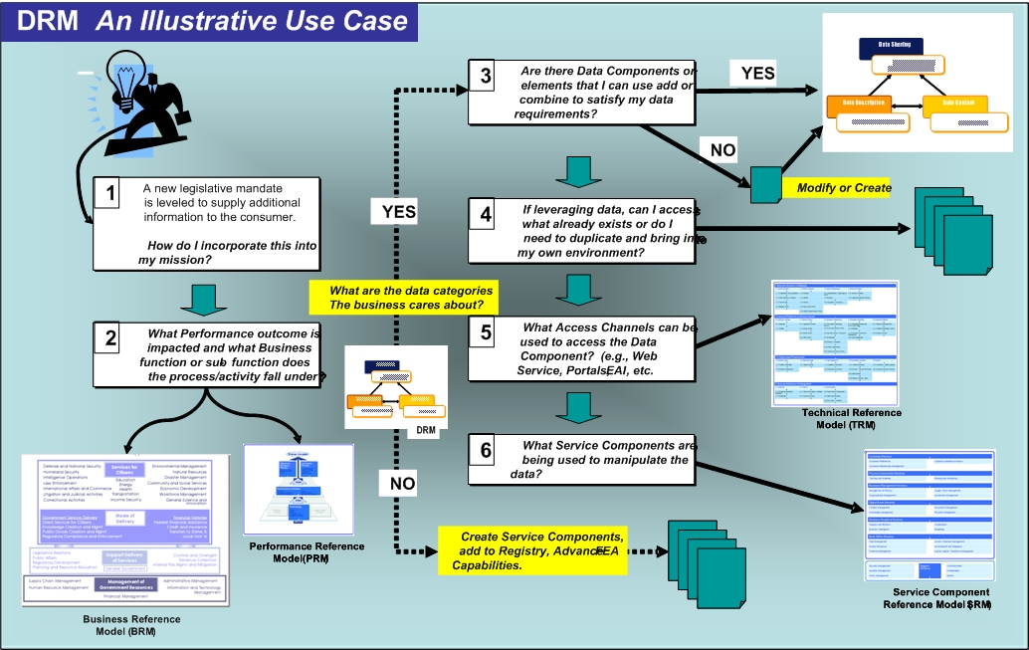

Figure 9. Example: The DRM’s Role Within the Context of A New Legislative Mandate.
2. Create the ability for rapid information sharing, data standardization, and data re-use through the DRM.
As new LoBs, E-Government initiatives or mission-driven interagency collaborations are established, the Federal departments and agencies involved will be required to use the DRM framework as a means to improve communications and to translate data artifacts and information between their organizations. Each effort will not have to reinvent the wheel in order to understand how multiple departments and agencies handle data architecture. They will either be able to tap into existing COIs or form new ones to meet their needs. This is another of the DRM’s real values: put forth a repeatable approach which facilitates the requirement for the Federal government to rapidly implement information sharing and reuse of data in response to business needs.
The COIs’ data standardization efforts will create the authoritative data source for that line of business, E-Government initiative or mission area.
The Federal government is highly decentralized in the way it manages data. Yet it is crucial that some commonly used data should be standardized, because they are so pervasive across multiple processes and services. The value of establishing some “core” data standards is that it could increase data interoperability between systems and more importantly governmental programs.
Beyond this, the Data Architecture Subcommittee, working with interested departments and agencies, will implement various pilots of the DRM, in order to explore how the DRM can be used to create more agile, responsive information characterized by rapid information sharing.
3. Assist agencies in the use of the DRM in order to facilitate compliance with Executive Branch policy, legislation, and legal mandates or decisions.
Recently drafted federal architecture principles state:
“Citizens’ needs determine how government functions are defined and delivered. Functions include direct services and regulating society to serve the public. … The Federal Government exists to serve the American public who want simpler, faster, better and cheaper access to government services and information.”
Agencies are held accountable to a variety of policy, guidance and oversight to improve government performance. For example, OMB Memorandum M-06-02 directs agencies to make full use of available search technologies when providing access for the public to government information. It calls for agencies to “…organize and categorize information intended for public access, make it searchable cross agencies, and describe how formal information models are used to assist dissemination activities.”
Of the three DRM standardization areas, Data Context plays a strong role in agency compliance with the memo. However, all three DRM standardization areas (i.e., Data Description, Data Sharing, Data Context) apply where formal information models are needed.

DRM – What are its strategic goals and outcomes?
Goal 1: Guide agencies in developing mature data architectures and management practices integral to their enterprise architectures by:
- Developing clear, concise and logical communications
- Identifying key stakeholders to include in the evolving communications
- Identifying COIs to assess required support
- Leveraging existing communications channels to make information readily
available

Outcomes:
1. Agencies are following the Three Pillar Data Strategy that includes business goals which are mission and customer results driven: Governance, Data Architecture, and Data Sharing Services that can be addressed in the EAAF, and the Exhibit 300 development.
2. Agencies have evidence of their Three Pillar Data Strategy implementations that are consistent with the DRM abstract model.
Sample Performance Measures:
- Increase in agency scores for the data architecture section of the OMB EA Assessment Framework.
- Decrease in the time between data being collected in the field before it is uploaded into government databases.
- Percentage of standard and/or ad hoc reports produced accurately and on time for internal and/or external stakeholders.

Goal 2: Create the ability for increased and expedited information sharing, data standardization, and data re-use through the evolving FEA DRM.
Outcomes:
1. Agencies enable business and customer results-driven and expedited information sharing through provisioning data services in accordance with the FEA DRM.
2. Agencies initiate or participate in COIs for existing cross-agency initiatives (Presidential E-Government initiatives and others); they have a formal data interoperability standard identified and recorded on a suitable platform.
3. Agencies initially identify and inventory data assets and formally appoint competent stewards for each data asset made available for sharing or reuse and exposed to the public. These actions are in response to the E-Government Act of 2002, OMB M-06-02, and OMB Circular A-130 and are consistent with the FEA DRM version 2.0 services for data sharing.
4. Major data assets are selected, inventoried and placed under stewardship when one or more of the following are true:
- It supports a core business function of the BRM,
- Data is purchased from an source external to the agency,
- Your agency enforces privacy or security controls over the data asset, and/or
- Your agency is the authoritative source for that data asset.

5. Agencies document their data assets as part of their enterprise architectures. Data assets available for sharing or reuse will be exposed using the Data Sharing Services and the Abstract Model delineated in the FEA DRM.
Sample Performance Measures:
- Increase in the number of inter-agency data sharing interfaces.
- Increase in the number of approved data standards used by two or more agencies.
- Percent of available population using a collaboration environment supporting Federal data management activities (e.g., DRM registry, etc.).
- Extent to which data or information is current (as measured in days since last update)
- Increase in the amount of data captured from electronic processes (rather than paper processes).
- Increase in agency adoption of approved E-Gov data standards (e.g., CHI).
- Increase in the percentage of data elements for which standards and definitions exist in an enterprise data dictionary (i.e., increased Data Standardization).
- Increase in the number of state/local governments exchanging data electronically with Federal agencies.
- Increase in the number of hardcopy records digitized, indexed, and/or catalogued.

Goal 3: Promote agencies’ use of the FEA DRM to support Public Access to Government Information. The DAS will provide related information and develop guidance as required in support of the strategic outcomes.
Outcome:
1. Agencies provide data sharing services in accordance with the FEA DRM to facilitate public access to government information.
2. Agencies ensure security and privacy capabilities that promote public access and information protection.
Sample Performance Measures
- Increase in the number of publicly available web services providing data in machine-readable form.
- Decrease in the amount of redundant data collected from citizens.
- Decrease in the amount of redundant data collected from citizens.
- Decrease in the number of redundant data sources (i.e., data sources duplicating data already provided by other agencies).
- Decrease in data request fulfillment time.
- Decrease in the average processing time for inter-agency data transactions.
- Increase in the number of unique visitors to cross-agency data exchanges / information sharing platforms (e.g., FirstGov.gov, Business.gov, Forms.gov, Export.gov, etc.).

APPENDIX A: List of Acronyms
BRM - Business Reference Model
CIO - Chief Information Officer
COI - Community of Interest
DRM - Data Reference Model
EAAF - Enterprise Architecture Assessment Framework
FEA - Federal Enterprise Architecture
GPRA - Government Performance and Results Act
IT - Information Technology
LOB - Line of Business
OMB - Office of Management & Budget
PRM - Performance Reference Model
SRM - Service Components Reference Model
TRM - Technical Reference Model

Information on the FEA can be found at http://www.whitehouse.gov/omb/egov/a-1-fea.html .
The DRM can be found at http://www.whitehouse.gov/omb/egov/a-5-drm.html .
The Business Reference Model (BRM), Performance Reference Model (PRM), Service Component Reference Model (SRM), and Technical Reference Model (TRM) have been incorporated into the Consolidated Reference Model (CRM), now at Version 2. As of this date, the CRM, containing these reference models, is available at www.whitehouse.gov/omb/egov/documents/FEA_CRM_v20_Final_June2006.pdf
This list is not intended to be all-inclusive. To understand your executive department’s or agency’s full range of responsibilities, please continue to refer to OMB Circular A-130 and other OMB policies. http://www.whitehouse.gov/omb/circulars/a130/a130trans4.html
Information on the FEA profiles and case studies can be found at http://www.whitehouse.gov/omb/egov/a-2-EAProfilesNEW2.html
Information on the EA Assessment Framework Version 2.0 (December 2005) can be found at http://www.whitehouse.gov/omb/egov/a-2-EAAssessment.html
This effort will reflect all existing policies regarding the use and development of voluntary consensus standards under OMB Circular A-119, NIST FIPS standards, and other appropriate policies and laws. http://www.whitehouse.gov/omb/circulars/a119/a119.html
For the full text of Improving Public Access to and Dissemination of Government Information and Using the Federal Enterprise Architecture Data Reference Model (OMB Memorandum M-06-02), December 16, 2005, see http://www.whitehouse.gov/omb/memoranda/fy2006/m06-02.pdf

